AngularJS 2 with Java Spring Boot

Use bootstrap and not jquery with AngularJS2 because they have different library components

Creating and Exporting pdfs with Angularjs 2: <https://www.npmjs.com/package/@types/jspdf>

Spring Boot My SQL Configuration:

http://zetcode.com/springboot/mysql/

<https://spring.io/guides/gs/accessing-data-mysql/>

mat

html2pdf

Lynda.com Tutorial

Expected Student Learning Outcomes/Objectives:

-Implementing user study

-proficiency in MVC, JavaScript, Java (Did a lot of research and I will be using AngularJS 2 with Java Spring Boot to fulfill this. It is a very neat way to implement the MVC framework)

-Software design diagrams (VISIO, these will include UML, Site Map, and Dataflow Diagram)

Grading/Evaluation Criteria

-fully functioning application

-report

Reading

-Clean Code ( <https://www.amazon.com/Clean-Code-Handbook-Software-Craftsmanship/dp/0132350882> )

From this criteria, I have also defined a few of the primary features of the application:

IT Resume Creator (will be able to export to .pdf)

IT Interview Flashcard Generator (Relevant questions prepopulated with the capability of having an admin for the site populate it with more)

IT Career Checklist (Good way to test out the communication between values in AngularJS and Spring Boot Java and show dynamic pages)

Tools:

Installed Eclipse, SpringBoot extension for Eclipse, Node, Gradle, and Postman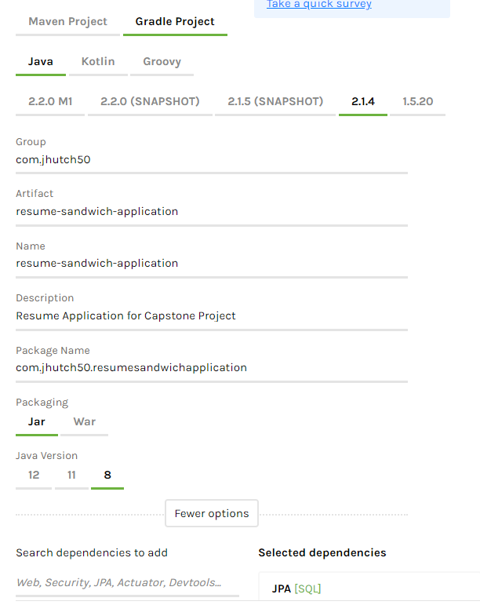

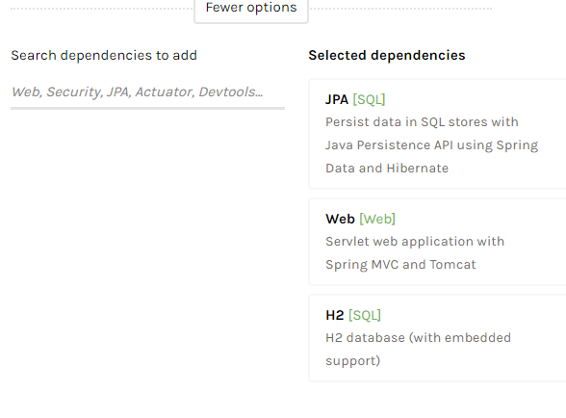

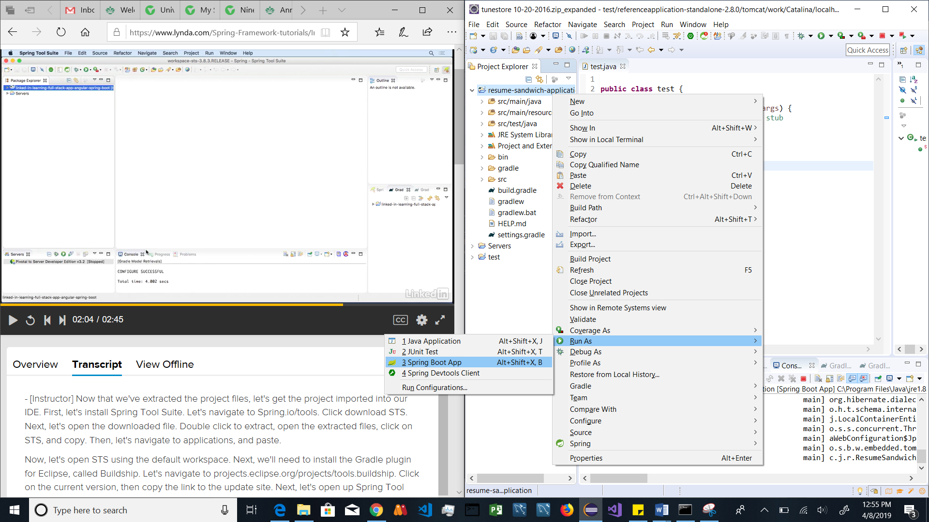

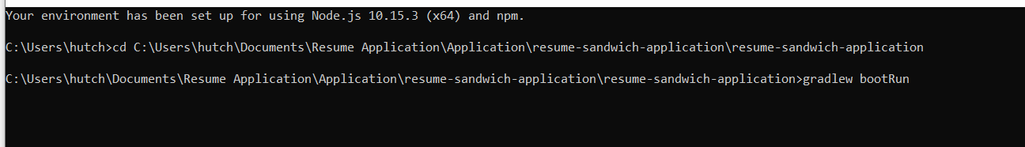

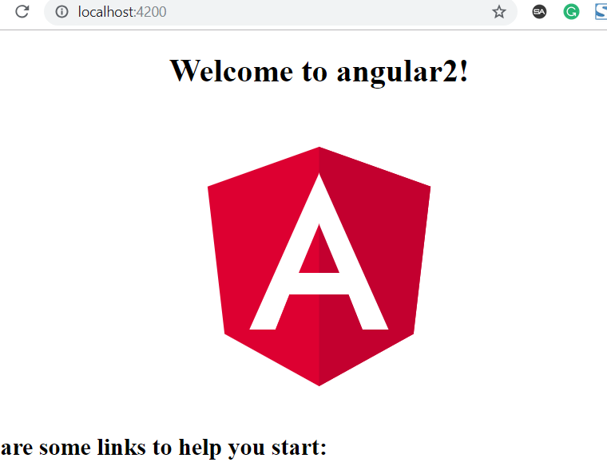

HTML

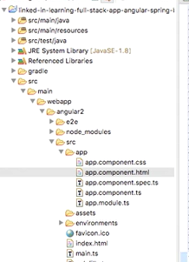

CSS

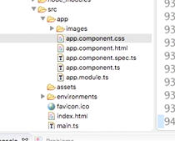

Images



<http://localhost:4200/> to test Angular JS2

ng serve inside the angular2 folder to run



cd Documents\Resume Application\Application\resume-sandwich-application\resume-sandwich-application\src\main\webapp\angular2

Testing

